AUTH-009
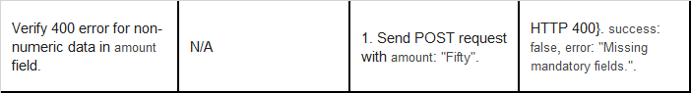
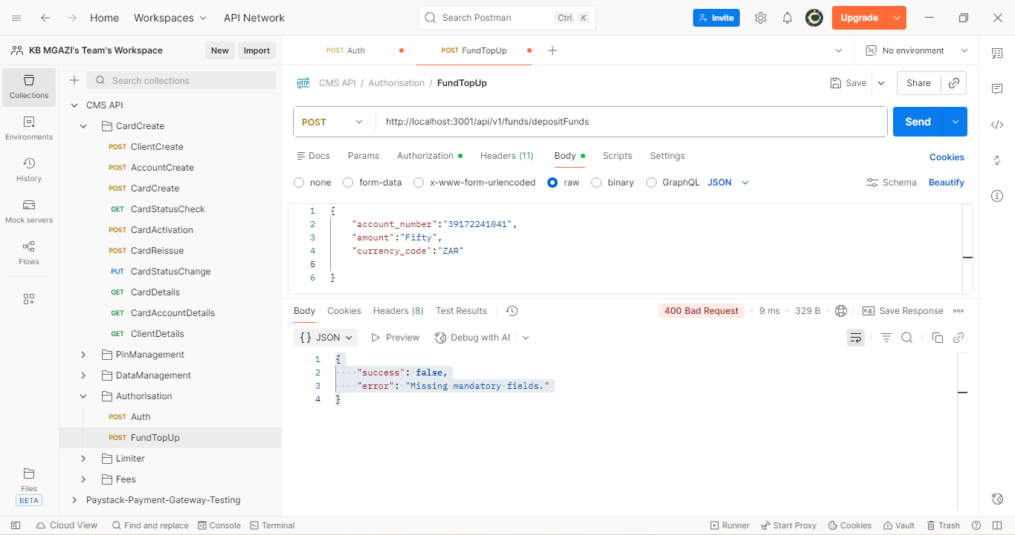
Request:
{
"account_number":"39172241041",
"amount":"Fifty",
"currency_code":"ZAR"

}
Response:
{
"success": false,
"error": "Missing mandatory fields."
}

